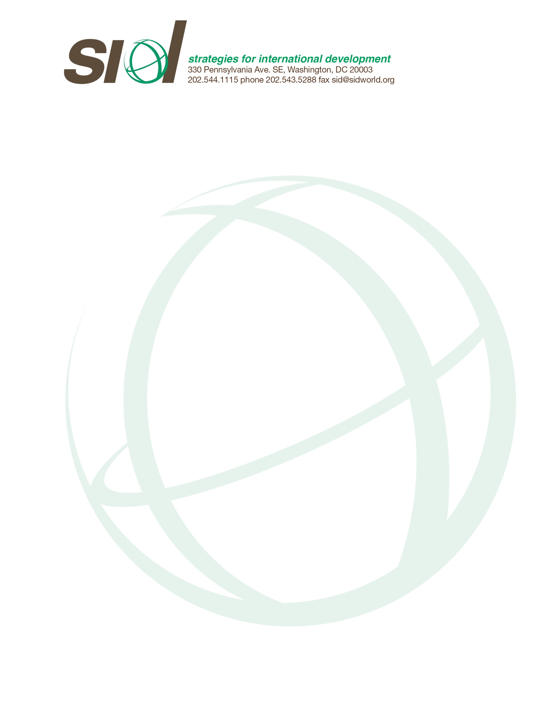

Title: Development Officer

Description
International Non-Profit is seeking an experienced and enthusiastic individual for the position of Development Officer.

Strategies for International Development (SID) develops, applies and promotes better methods for eradicating rural poverty. SID works in Guatemala, Perú, and Bolivia, the three countries in Central and South America with the greatest number of rural poor, most of whom are Native American farmers. Using progressive methodologies, SID helps poor farmers graduate from poverty. We help them adopt business as well as better farming practices. The farming practices increase their productivity, value-added processing, and income. The business practices ensure that they become self-reliant commercial farmers. We also help farmers reclaim and conserve their land so their farms can be sustained for generations. Finally, we ensure that women participate equally in the technical assistance and benefits of each project.

SID derives most of its funding from small U.S Foundation and some individual donors. SID has a solid core of funding from family foundations, but we would like to expand our foundation funding to include large foundations as well. We are therefore looking for a Development Officer who will pursue opportunities of entry into large foundations and secure funding from them. In addition, we are also looking to expand our network of individual donors.

Responsibilities
The Development Officer will be responsible for:

- Raising the funds to close the gap between current funding and the resources our projects require
- Developing a plan of action for the sources of funding to be pursued, with the Plan to be presented to the Central Office and the Board of Directors
- Generating monthly reports to the Central Office and the Board of Directors
- Presenting a progress report with early indicators of success 3 months after starting the job
- Presenting a success report of grants received at the 6 and 11 months mark

The Development Officer will begin operations in May 2017, for a period of one year, with the possibility of renewing the contract based on performance. Central Office will support the Development Officer with all the materials, information, and contacts necessary. Staff will also attend meetings when appropriate.

Qualifications
- 5-15 years of experience in fundraising
- Excellent verbal and written communication skills
- Self starter and goal-driven to pursue donor visits and calls
- Organized and mission oriented
- Bachelor’s Degree Required. Master’s Degree Preferred

Salary
$60,000 to $80,000 depending on experience

Interested candidates should e-mail résumé and cover letter to jquintal@sidworld.org.

